
The Dinner Plate:
A Metaphor for Life
How to Develop Your Child
as a Leader
Petran Unlimited
“Building leaders and communities through the Kitchen”
Phone: 310.283.1779
Email: michael@petranunlimited.com
Website: http://www.petranunlimited.com
© Petran Unlimited, 2009
Leadership Begins in the Kitchen®
Dr. Michael Petran is President of Petran Unlimited, a leadership development consulting company. In his 20+ year career, he has worked with a wide range of organizations from small non-profits to Fortune 500 companies. With a Doctorate in Organizational Leadership (Ed.D.), his experience also extends into the kitchen where he received culinary training at the Le Cordon Bleu, Paris. Additionally, he serves as adjunct faculty at UC Irvine where he teaches business strategy and leadership.
Next Presentation – Complimentary

Limited Seating
RSVP: michael@petranunlimited.com
Menu
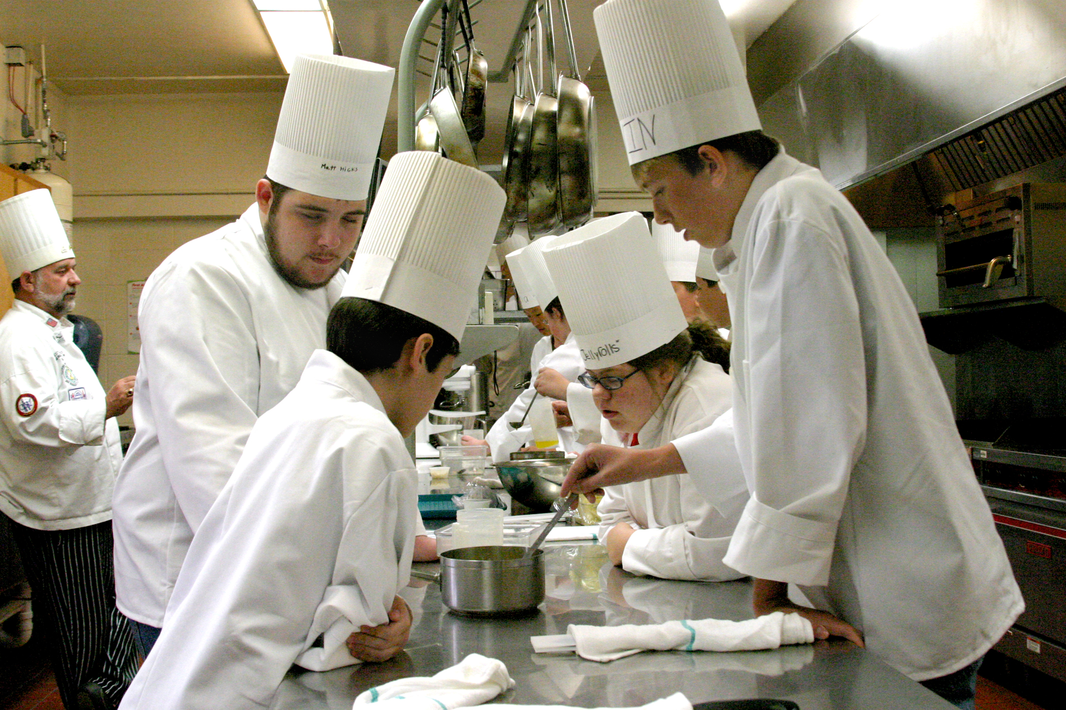

First Course

French Onion Soup – Honesty/Integrity
Sweet onions, leeks, shallots, and garlic with fennel croutons
Entrées

Roasted Prime Ribs of Beef – Communication Skills (Verbal and Written)
Prepared in the traditional manner

Stuffed Portobello Mushroom in a Puff Pastry – Character
Warm spinach stuffed portobello mushrooms wrapped in a puff pastry

Potato Crusted Salmon – Competence

Yukon gold potato and horseradish crust, topped with smoky mustard sauce

Side Dishes

Cranberry-Mango Relish – Interpersonal Skills
Fresh cranberries combined with the sweetness and texture of mangoes.

Twice Baked Potatoes – Teamwork Skills

A classic twice-baked potato mashed with sour cream, milk, butter, and mixed in with crumbled bacon, green onions, and grated cheddar cheese.

Saffron Couscous– Self-motivation/Initiative

Earthy saffron couscous flavor is lifted by red peppers, green onions, and shallots.

Brussels Sprouts and Mushrooms with Rosemary – Strong Work Ethic

A combination of Brussels sprouts and fresh mushrooms served with the aroma and flavor of fresh rosemary

Avocado with Broccoli and Carrot Slaw – Analytical Skills

Crisp, shredded broccoli and carrot matched with buttery avocado.

Asparagus Hollandaise – Technology Skills

The sublime marriage of fresh asparagus and a rich and creamy hollandaise sauce

Grilled Vegetables Shish Kebab – Organizational Skills
Assorted seasonal vegetables marinated in a sweet and sour sauce.

Polenta with Vegetables – Creative Minds

A medley of vegetables served over a mound of fluffy polenta.
Desserts

Dark Chocolate Tart with Gingersnap Crust – Courage

A rich and silky tart with black pepper and crystallized ginger to add a little punch.

Caramelized Banana Splits with Hot Chocolate Sauce – Humility
With its warm, gooey goodness, this dessert will bring bananas Foster to mind.

Fruit Plate – Fun
Fresh seasonal fruits.

